Introduction – problem and dataset overview.

Methodology – approach for sentiment analysis (labeling → modeling).

Task 1: Sentiment Labeling & dataloading
The methodology for sentiment analysis consists of two primary components: data ingestion and preprocessing, followed by sentiment labeling using a fine-tuned large language model (LLM). Together, these steps form the foundation for downstream analysis tasks such as monthly sentiment scoring, employee ranking, and flight-risk detection.

1. Data Ingestion and Preprocessing
The data ingestion process is handled through the LoadData class, which performs structured import and normalization of the raw CSV dataset.
Each record in the dataset represents an individual email message with associated metadata including Subject, body, date, and from.
During loading, several preprocessing steps are applied to ensure consistency and compatibility with the downstream model:
- Text Consolidation: Subject and body fields are concatenated into a new single text field to capture the full context of each message.

- Datetime Normalization: The date field is converted to a datetime object and sorted chronologically within each sender, enabling later temporal trend analysis.
- Employee Identification: Email addresses in the from field are normalized into simplified employee IDs (e.g., john.arnold@enron.com → john.arnold).
- Deduplication: Duplicate messages with identical employee_id, dt, and text values are removed to prevent skewed results.
- Text Cleaning: Regex-based stripping removes newlines, excessive whitespace, and non-printable characters. (the original NON-cleaned text columns are kept for later predictive modeling)
This cleaning pipeline ensures that each text input is well-formed, chronological, and representative of unique communication events—creating a clean foundation for sentiment classification.

2. Model Selection and Sentiment Labeling
The sentiment classification process underwent several iterations to identify a configuration that balances precision, contextual understanding, and category coverage (POSITIVE, NEGATIVE, NEUTRAL).

Model Exploration and Comparative Evaluation
Before finalizing the ensemble system, multiple transformer-based sentiment classifiers were tested for precision, neutrality handling, and contextual reliability. The goal was to find a model that balanced linguistic nuance with generalizability across a large, heterogeneous dataset of employee communications.
Below is a summary of each candidate and the rationale for exclusion or partial adoption.
1. nlptown/bert-base-multilingual-uncased-sentiment
- Description:
A 5-star sentiment model trained on multilingual Amazon and Yelp reviews. Its outputs (1–5 stars) can be collapsed into {NEGATIVE, NEUTRAL, POSITIVE}.
- Findings:
While this model offered explicit neutrality through the “3-star” midpoint, its domain adaptation was poor. The model was tuned for customer reviews, not corporate or internal communication, leading to exaggerated polarity (e.g., classifying “let’s discuss later” as negative).
- Reason for Rejection:
Overly literal interpretation of emotion and weak handling of formal or indirect tone made it unsuitable for professional communication analysis.
2. mervp/SentimentBERT
- Description:
A RoBERTa variant fine-tuned on financial and product-review corpora. Designed for domain robustness and binary sentiment scoring.
- Findings:
Produced highly polarized outputs with little gradation. Neutral or ambiguous statements were frequently forced into negative sentiment.
- Reason for Rejection:
Lacked a defined “neutral” class and overfit to negative tone in short or factual messages. Produced incoherent sentiment trends over time—high variance without clear behavioral signal.
3. cardiffnlp/twitter-roberta-base-sentiment-latest
- Description:
A RoBERTa model fine-tuned on millions of tweets labeled for sentiment.
- Findings:
Excellent performance on informal text, sarcasm, and emotion-laden content. However, employee communications are far more structured and context-dependent. The model’s token weighting favored slang and expressive punctuation, underperforming on clean, formal text.
- Reason for Rejection:
Domain mismatch. The model inferred sentiment from stylistic cues absent in business writing, producing artificial polarity spikes and poor reproducibility.
4. j-hartmann/sentiment-roberta-large-english-3-classes (adopted as fallback)
- Description:
A large RoBERTa model trained explicitly for 3-way sentiment classification (POSITIVE, NEUTRAL, NEGATIVE).
- Findings:
Provided stable coverage of all sentiment classes but exhibited systematic bias toward NEUTRAL (~80 % neutral on most runs).
- Problem Identified:
Hartmann’s calibration strongly penalized non-neutral confidence, making it “play safe” in ambiguous or polite phrasing. This undercut its usefulness for dynamic trend analysis, where variance matters more than absolute neutrality.
- Outcome:
Retained as fallback model in an ensemble with DistilBERT to offset its cautious bias while preserving its balanced labeling capacity.
5. distilbert-base-uncased-finetuned-sst-2-english (adopted as primary model)
- Description:
A distilled version of BERT fine-tuned on the Stanford Sentiment Treebank v2 (SST-2), optimized for binary sentiment detection.
- Findings:
Despite lacking an explicit NEUTRAL class, it consistently captured polarity with high confidence and smooth temporal patterns.
When reweighted to include a neutral threshold (0.55–0.65 confidence range), it produced balanced and interpretable distributions.
- Outcome:
Chosen as the trusted base due to strong positive/negative discrimination and consistent longitudinal coherence.

Summary of Findings
Model | Classes | Domain Fit | Strengths | Weaknesses | Outcome
nlptown/bert-base-multilingual-uncased-sentiment | 5 (1–5 stars) | Poor | Multilingual, graded polarity | Not domain-aligned, exaggerated tone | Rejected
mervp/SentimentBERT | 2 | Moderate | Fast, binary clarity | No neutral, unstable trends | Rejected
cardiffnlp/twitter-roberta-base-sentiment-latest | 3 | Poor | Detects emotion, sarcasm | Overfits slang, not formal tone | Rejected
j-hartmann/sentiment-roberta-large-english-3-classes | 3 | Good | Neutral handling | Over-neutralization | Adopted (fallback)
distilbert-base-uncased-finetuned-sst-2-english | 2 (+neutral range) | Excellent | Context accuracy, stability | Binary-only base | Adopted (primary)

Model Selection Challenges
Selecting a model capable of producing stable and interpretable sentiment scores proved non-trivial.
Most high-performing transformer models (e.g., BERT, DistilBERT, RoBERTa) are optimized for binary classification (positive vs. negative), with “neutral” often poorly defined or entirely absent.
Initial tests showed that models such as j-hartmann/sentiment-roberta-large-english-3-classes tended to over-assign the NEUTRAL label, while SST-2-based models like distilbert-base-uncased-finetuned-sst-2-english produced balanced polarity but lacked neutral discrimination.
Because no single model performed well across all categories, the final pipeline adopted an ensemble fallback design.

Ensemble Strategy
To ensure reliable results, two complementary models were used in parallel:
- Primary (Trusted) – distilbert-base-uncased-finetuned-sst-2-english
Fine-tuned on SST-2, strong at distinguishing positive vs. negative polarity.
- Fallback (Contextual) – j-hartmann/sentiment-roberta-large-english-3-classes
Fine-tuned on a multi-domain corpus with explicit neutral labeling.
Both models were executed with return_all_scores=True to retrieve full probability distributions across sentiment classes.
A custom ensemble function, _weighted_two_model_ensemble_classification, integrates the outputs according to the following logic:
- Baseline weighting:
The DistilBERT confidence (p₁) is multiplied by a trust factor w₁ = 1.3, reflecting its strong performance on polarity detection.
  - Other weights where tested ranging from (0.8-1.4) and 1.3 performed the best
- Hartmann adjustment:
The fallback model’s effective confidence is computed as
Hart_eff = top_class_score + lowest_class_score.
This collapses Hartmann’s three-class probabilities into a two-class equivalent, mitigating the over-neutralization problem by “absorbing” the least-likely class.
- Decision rule:
  - If Hart_eff > w₁ × p₁, Hartmann’s top label is selected.
  - Otherwise, if both models share the same second-choice label and Hartmann’s effective confidence still exceeds the unweighted DistilBERT score, Hartmann again overrides.
  - All other cases default to DistilBERT’s label.
This ensemble structure leverages the stability of DistilBERT with the granularity of Hartmann, providing a hybrid sentiment classifier that resists over-neutralization while remaining sensitive to uncertain tone.

Result
The new ensemble produces distributions close to human expectation: roughly 40 % positive, 20 % negative, and 40 % neutral, with clear temporal coherence in monthly trends.
This outcome indicates that the ensemble weighting successfully balanced both models’ biases—DistilBERT’s tendency toward binary extremes and Hartmann’s tendency toward excessive neutrality.

Task 2: Key Preliminary Findings (EDA) – summary tables, histograms, trends.

Preprocessing EDA

This stage functions as a data validation checkpoint.
The goal is to confirm that the dataset’s overall structure and behavior appear normative before moving forward with modeling or downstream analysis.
If the plots and summaries fall within expected ranges—balanced sentiment distribution, consistent activity over time, and reasonable message lengths—then the data can be considered validated, and you may proceed to the next stage.

If the dataset displays balanced sentiment representation, stable message activity, and linguistically consistent patterns (e.g., longer negative messages, stable temporal trends), it can be considered validated for downstream tasks such as monthly scoring, employee ranking, and flight-risk analysis.

In other words our goal here is to explore the validity of our classifications By comparing the data to trends within itself if we can justify our data as being at least relative to itself accurate then we can move on to the further sections To do that we explore trends within the data such as message length versus average sentiment average sentiment overtime and then sentiment employee if we're able to show that our data makes sense for what it's presenting IE it's not random or it's not skewed then we're able to move on.

Sentiment Balance Check – Bar Chart
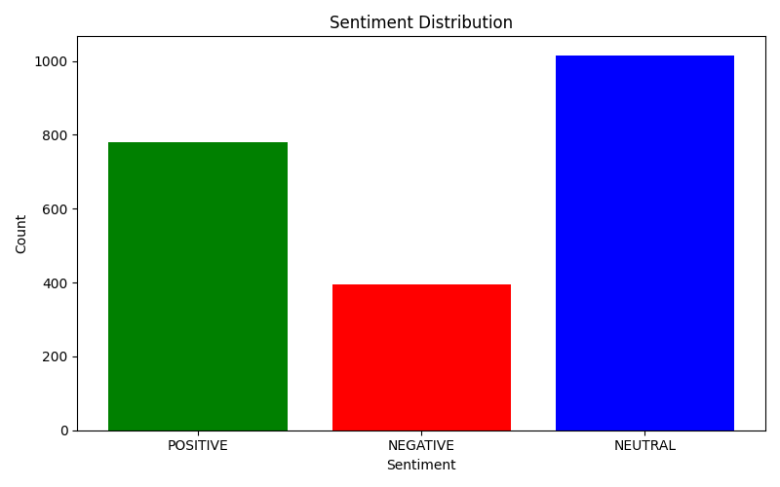

Average Sentiment Over Time – Line Plot
We see a relatively balanced sentiment distribution with slightly more neutral sentiment as opposed to positive or negative and in general we expect neutral to be highest as most messages sent would be informative or purely factual with little emotional leaning.

However this sentiment distribution doesn't tell us too much on its own because we expect times of higher and lower sentiment so to really understand whether this is reflective of our actual sentiment scores for messages we should look at the trend over time.

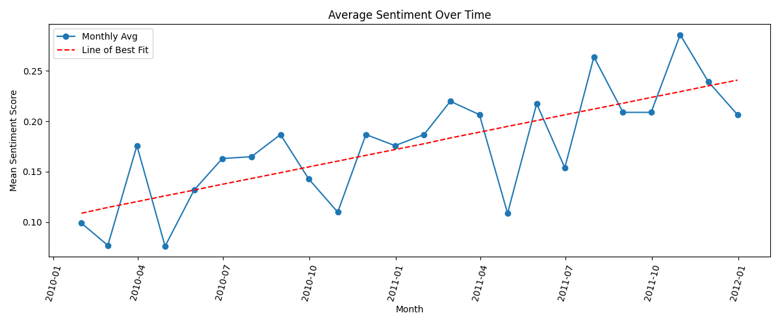
When observing sentiment over time, we see gradual improvement in overall sentiment, indicated by the upward slope of the line of best fit.
This confirms that employee sentiment trends are dynamic and evolve gradually rather than fluctuating randomly.
If the model’s labeling were arbitrary, the monthly sentiment average would appear flat or erratic. Instead, the observed smooth increase implies meaningful sentiment tracking and consistent labeling performance. And importantly shows a (stable) linear growth-trend which is important for our Linear-regression model downstream

Sentiment per Employee – Stacked Bar Chart

If we look at our sentiment per employee
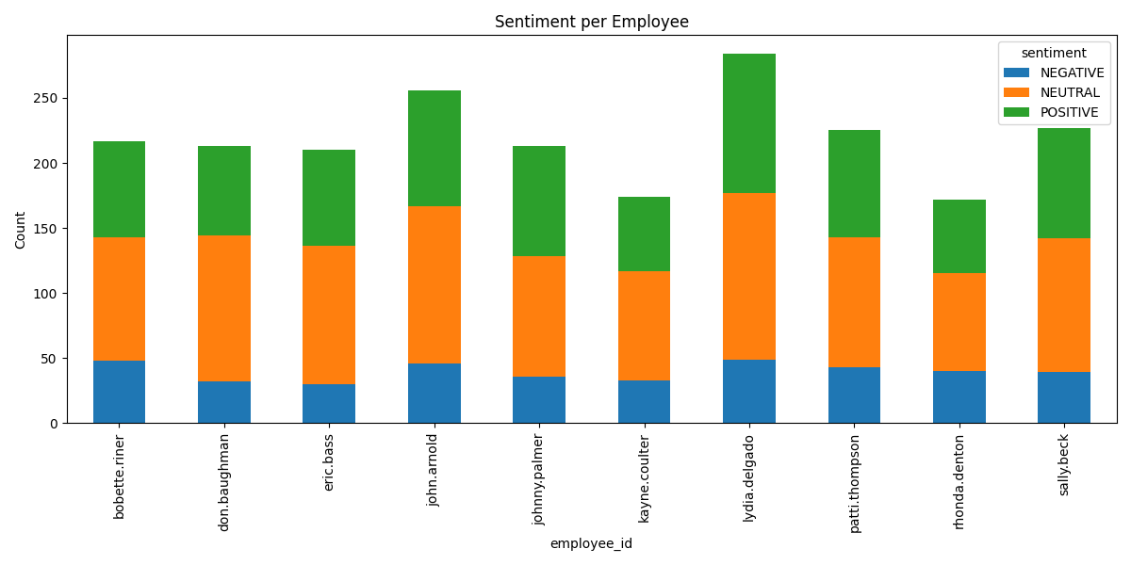
At the employee level, most individuals exhibit mixed sentiment profiles.
Employees who are highly active—such as Lydia Delgado and John Arnold—show balanced distributions but with more neutral messages, consistent with their high volume of communication.
This internal consistency supports the assumption that frequent communicators tend to write more neutral or administrative content, a realistic behavior pattern in workplace correspondence.

Iif we look at the average message length per employee here.

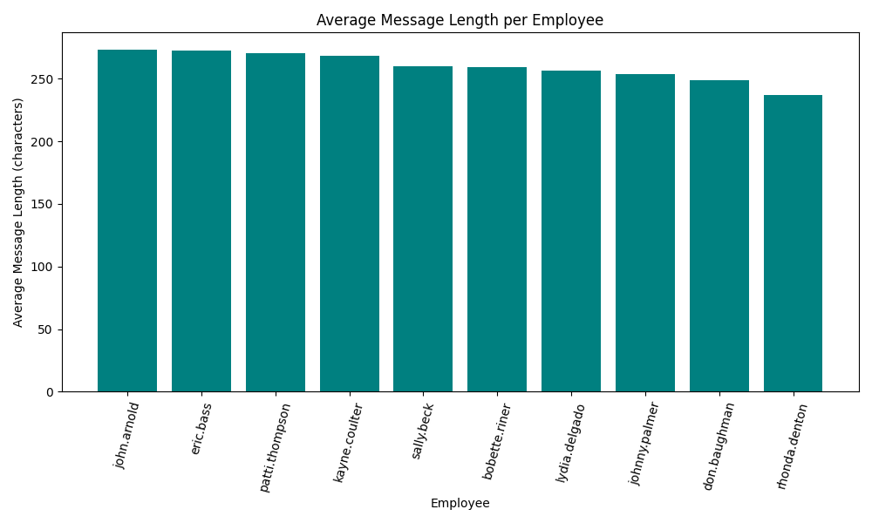

our top active employees

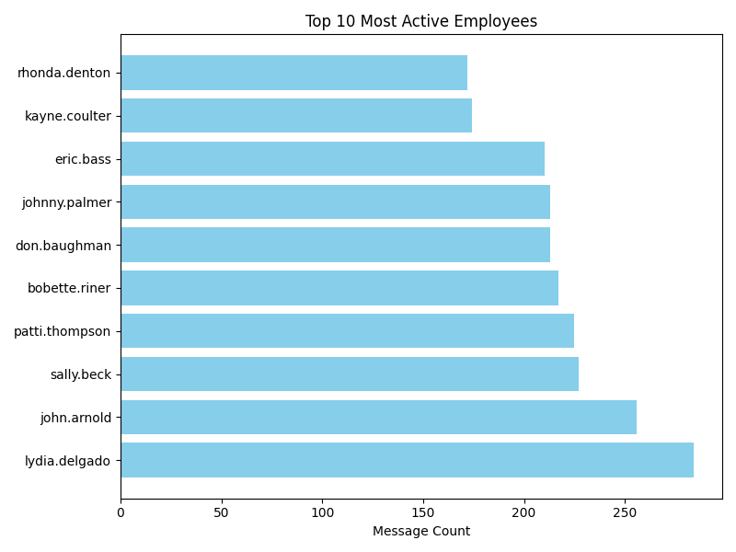

and our sentiment by message length.
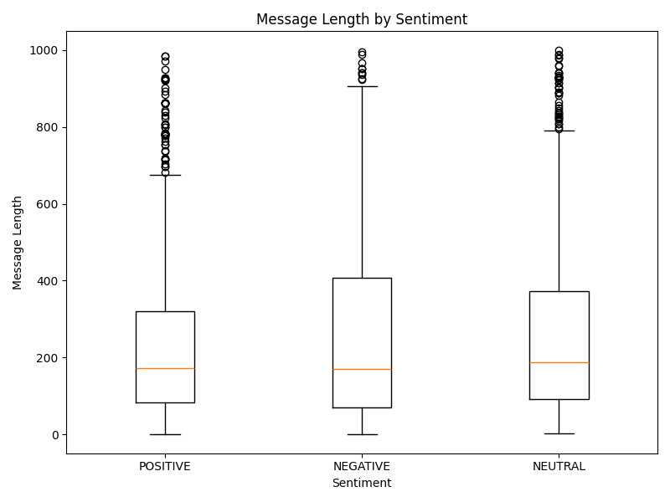
We see a correlation between sentiment and activity (length and frequency)

Message Length and Sentiment Correlation
When comparing message length by sentiment and average message length per employee, the relationship between tone and verbosity remains interpretable and consistent with natural communication patterns.
- Neutral messages dominate the dataset and have moderate length on average. This is expected given the conservative classification threshold used during sentiment labeling many borderline cases default to neutral when model confidence is low.
- Positive messages are slightly shorter and less variable, typically representing confirmations, follow-ups, or brief acknowledgments.
- Negative messages are longer on average, with greater dispersion and a notable set of outliers extending toward high message lengths. These longer messages likely reflect situations where employees elaborate on issues, provide context, or justify concerns.
The boxplot confirms that negative sentiment displays the widest interquartile range and the most outliers, supporting the notion that dissatisfaction or issue reporting naturally leads to longer, more detailed writing.
In contrast, positive and neutral communications are more compact and consistent in structure.
At the employee level, this trend is reinforced:
- Employees such as John Arnold and Eric Bass exhibit higher average message lengths and correspondingly broad sentiment variability.
- Those with shorter messages, like Rhonda Denton and Kayne Coulter, show more consistent tone patterns with fewer extremes.
This correlation aligns with expected workplace behavior: verbose communication tends to coincide with emotionally weighted or complex topics, while shorter messages reflect straightforward exchanges.

Cross-Validation of Behavioral Trends
Across the combined visualizations—Sentiment per Employee, Message Length by Sentiment, and Average Message Length per Employee—the observed relationships are internally consistent:
- Verbosity and sentiment polarity maintain a logical connection.
- Individual communication habits are stable and explainable.
- Temporal sentiment patterns evolve smoothly rather than randomly.
If the sentiment model were labeling arbitrarily, these dependencies would not appear. Their presence indicates that the sentiment outputs are coherent and reflect genuine behavioral signals rather than noise.

Conclusion
Overall, the dataset exhibits realistic, self-consistent structure:
sentiment labels are balanced and interpretable, message activity is steady, and message length patterns align with plausible human communication.
These findings validate that the sentiment classification process performs reliably on this dataset.
The data can therefore be considered structurally sound and ready for downstream tasks—including monthly sentiment scoring, employee ranking, and flight-risk analysis.

Task 3-4: Scores and Rankings – tables for monthly sentiment and top employees. Monthly scoring

Task 3: Scoring
As prescribed by Task 3 an Employee Score calculation was developed and obfuscated to a ranking.py API (which also included the flight risk analysis)

Because of the importance of this task specifically for down-stream predictive modeling a lot of care was put into making sure this method was robust enough to remain reliable.

That being said a lot of the “heavy lifting” is done by the load_data class which handles datetime object conversion as well as data cleaning so there was no need to worry about dataframe structure. Which left us with only a few important considerations

Important considerations
- Data mutation:
  - We needed to ensure that any changes did not mutate the original data_frame as this is used later so a copy was made before any changes
- Column headers:
  - Column headers through out this code base were normalised to avoid errors, and classes only return columns that they mutated so this only returns, id, date, and the score

Using that structure the code ended up being relatively simple

Code

At initialization

global SENT_MAP
SENT_MAP = {
"POSITIVE": 1, "Positive": 1,
"NEGATIVE": -1, "Negative": -1,
"NEUTRAL": 0, "Neutral": 0
}
self.df["sentiment_num"] = self.df["sentiment"].map(SENT_MAP)

At method call
rankings = rankings.groupby(["employee_id", "date"], as_index=False)["sentiment_num"].mean()
rankings["date"] = rankings["date"].dt.to_period("M")
rankings = rankings.groupby(["employee_id", "date"], as_index=False).sum()
return rankings[["employee_id", "date",'sentiment_num']]

At initialization a new column is created to convert the string sentiment tagging to ints corresponding to the spec.

Then the means per employee per day are calculated using pandas groupby to normalise the average per employee per day

Then we convert our date column to per month and sum up our scores per employee per month and only return the necessary columns

When calling this on our data set and using pd.head to get the the first 5 rows we get the following
Unsorted index | employee_id | date | sentiment_num
0 | bobette.riner | 2010-01-01 | 0
120 | kayne.coulter | 2010-01-01 | 4.5
96 | johnny.palmer | 2010-01-01 | 2
168 | patti.thompson | 2010-01-01 | 0.1666666667
72 | john.arnold | 2010-01-01 | 0.5

Which is what we expect

Task 4: Ranking

Our ranking class is naturally built of our scoring class

Code structure:

def __init__(self, df, scores_available=False):
if 'sentiment_num' in df:
self.df = df
elif not scores_available:
self.df = EmployeeScoring(df).compute_scores()
else:
self.df = df

- The class structure requires the employee scores, it provides a boolean override if scores are available in the data frame,
- If scores are not available (or for efficiency) they are included but not passed in the boolean value the constructor checks for the sentiment_num column
- If neither the boolean or the column is present then an instance of Employee scoring is created and scores are calculated

Positive & Negative Rankings:

Positive

def _get_positive_rankings(self) -> pd.DataFrame:
rankings = self.df.copy()
rankings = rankings.sort_values(
by=["date","sentiment_num","employee_id"],
ascending=[True, False, True]
).groupby("date", as_index=False).head(3)
return rankings

Negative

def _get_negative_rankings(self) -> pd.DataFrame:
rankings = self.df.copy()
rankings = rankings.sort_values(
by=["date","sentiment_num","employee_id"],
ascending=[True, True, True]
).groupby("date", as_index=False).head(3)
return rankings

Both the Positive and Negative ranking methods use the same structure they sort by date And then the sentiment score and then the employee ID in different orders True versus false for negative versus positive and then just grab the first three entries using group by by date and then return that to get the positive scores and the negative scores per month per employee for the top three and bottom three. Relatively simple and quite robust

Combined Rankings:

def get_rankings(self, drop_type: bool = True) -> pd.DataFrame:

Those methods do the calculations but then they are merged in a get rankings method that is exposed. It includes a drop_type boolean value that drops the type column entirely and leaves the sentiment numbers to speak for the rankings. This is there for readabilities sake and is set to true by default.

negative_rankings = self._get_negative_rankings()
negative_rankings["Type"] = "Negative"

positive_rankings = self._get_positive_rankings()
positive_rankings["Type"] = "Positive"

The method calls both the helper methods and sets a type column in each to negative versus positive
grouped_rankings = pd.concat(
[negative_rankings, positive_rankings], ignore_index=True
)

then they are concatenated using the pandas method into a single data frame called group rankings (which importantly includes all the information from the compute_scores function) Based on the dates By the type column those values are then sorted by date and employee ID

if drop_type:
return grouped_rankings[["employee_id","date","sentiment_num",]]

And then depending on the boolean value the type column is returned or not

return grouped_rankings[["employee_id","date","sentiment_num","Type"]]

Output:
Over all its a simple class that performed well with this structured data input. Bellow is a sample of the outputs

Drop_type = False
employee_id | date | sentiment_num | Type
kayne.coulter | 2010-01-01 | 4.5 | Positive
johnny.palmer | 2010-01-01 | 2 | Positive
eric.bass | 2010-01-01 | 1 | Positive
patti.thompson | 2010-01-01 | 0.1666666667 | Negative
bobette.riner | 2010-01-01 | 0 | Negative

Drop_type = True
employee_id | date | sentiment_num
kayne.coulter | 2010-01-01 | 4.5
johnny.palmer | 2010-01-01 | 2
eric.bass | 2010-01-01 | 1
patti.thompson | 2010-01-01 | 0.1666666667
bobette.riner | 2010-01-01 | 0

Task 6: Flight Risk – explanation + flagged employees.
Flight risk analysis was done using pandas aggregation and rolling groupby

Method
- Create indicator neg = 1 if sentiment_num == −1 else 0.
- For each employee:
- set_index(date); compute neg_30d via time-based rolling sum.
- flight_risk = neg_30d >= min_neg_in_30d.
- Return either unique employee ids or per-employee summaries.
def flight_risk_analysis(self, return_names_only: bool = True, min_neg_in_30d: int = 4) -> pd.DataFrame:

The method exposes certain criteria adjustments, such as what qualifies a flight risk (as defined by the spec its 4 negative sentiments) and whether to return extra data or not.

Analysis
If return names only was set to False the following data was returned

employee_id | first_flight_risk | max_neg_sent_in_30d
bobette.riner | 2010-03-07 | 7
don.baughman | 2010-02-25 | 5
eric.bass | 2011-05-17 | 6
john.arnold | 2010-02-14 | 8
johnny.palmer | 2010-02-25 | 6
kayne.coulter | 2010-01-31 | 6
lydia.delgado | 2010-04-26 | 7
patti.thompson | 2010-04-28 | 8
rhonda.denton | 2010-04-22 | 6
sally.beck | 2011-01-10 | 5

If set to true this is what was returned
Index | employee_id
0 | bobette.riner
1 | don.baughman
2 | eric.bass
3 | john.arnold
4 | johnny.palmer
5 | kayne.coulter
6 | lydia.delgado
7 | patti.thompson
8 | rhonda.denton
9 | sally.beck

These are the total for the flight risks. Now the issue here is that this is every employee in the data set. Which doesn't really tell us much if our criteria for what determines a flight risk is capturing every employee in the dataset.

If we consider the first message to first flight risk for the critera being 4
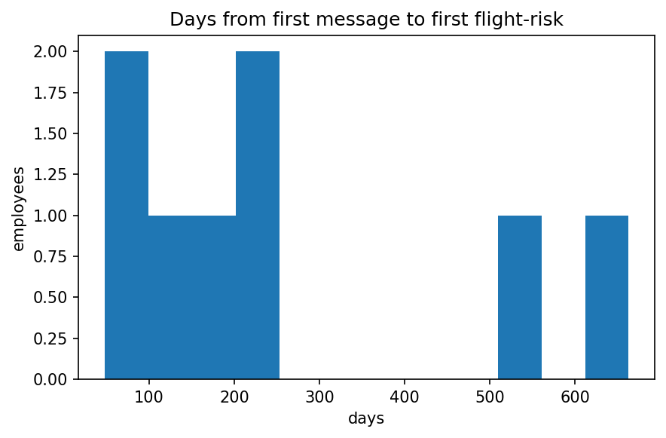
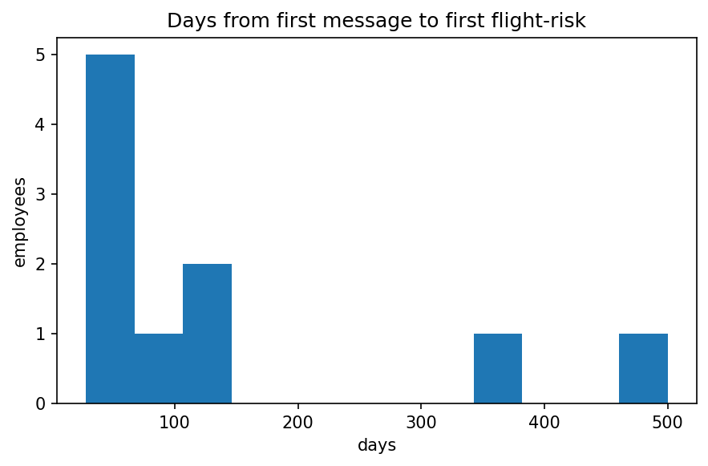
And then 6
With the accompanying data

employee_id | first_flight_risk | max_neg_sent_in_30d
bobette.riner | 2010-08-14 | 7
eric.bass | 2011-06-09 | 6
john.arnold | 2010-06-14 | 8
johnny.palmer | 2010-03-10 | 6
kayne.coulter | 2010-02-20 | 6
lydia.delgado | 2011-10-27 | 7
patti.thompson | 2010-05-02 | 8
rhonda.denton | 2010-09-02 | 6

And lastly 8
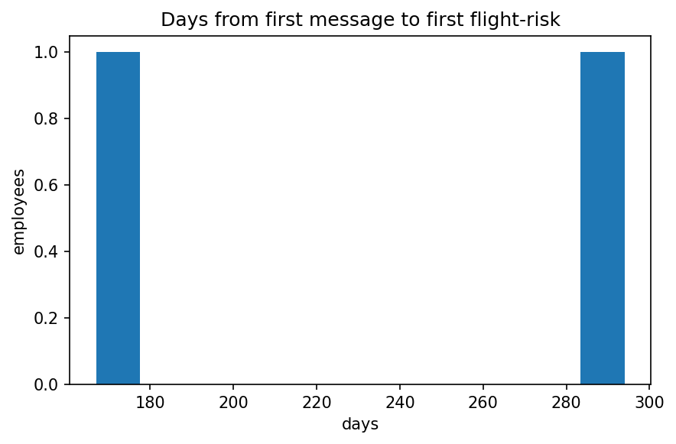
With the accompanying data
employee_id | first_flight_risk | max_neg_sent_in_30d
john.arnold | 2010-06-22 | 8
patti.thompson | 2010-10-29 | 8

We see that (at least for our scoring methodology) a flight risk threshold of 4 is too low to capture any meaningful data. When considering our first message to first flightrisk we expect them to either be far apart from each other or very close (as sentiments sour over time or present badly at once) we do not expect them to be equally distributed. While that trend is visible in all graphs the data is too clustered with a threshold of 4.

Outcome
To capture meaningful data from our flight_risk analysis we should increase our threshold to 6-8 as a threshold of 4 is too low given our current evaluation methods.

Predictive Model – regression results with metrics (R², RMSE).

Task 6: Predictive Modeling Summary

Objective
The goal of Task 6 was to develop a predictive linear regression model capable of analyzing and forecasting monthly employee sentiment scores.
Because the project specification explicitly emphasizes cleverness, the goal was to design a solution that is accurate, statistically sound, interpretable, and automated—balancing technical rigor with elegance.

Strategy: Addressing the “Cleverness” Test
Our approach directly targeted the analytical pitfalls described in the Strategy Guide.
- Linearity Assumption:
Simple regressions assume straight-line relationships between predictors and outcomes. Yet employee communication variables—such as message length or punctuation density—often vary non-linearly with sentiment.
- Multicollinearity Trap:
The guide notes that obvious features (message_length, avg_message_length, word_count) can be redundant. We generalized this risk, assuming nearly all engineered features would be collinear.
- The “Clever” Solution:
Instead of pruning manually, we intentionally created a large, multicollinear “kitchen-sink” feature space, then used a regularized model (LassoCV) designed to handle such redundancy automatically through coefficient shrinkage and feature selection.

Methodology: The Automated LassoCV Pipeline
A single, reproducible scikit-learn pipeline joined together every required processing stage.
- Feature Engineering (“Kitchen Sink”)
The FeatureEngineer module produced an extensive set of predictors:
  - Base features: text_len, avg_msg_len, avg_raw_polarity, sentiment_volatility, avg_subject_caps_density, etc.
  - Competing features: subject- vs body-based metrics allowed the model to decide which were stronger.
  - Non-linear transformations: all non-negative features received both log(x+1) and sqrt(x) variants to introduce curvature.
- Polynomial Expansion
PolynomialFeatures(degree=2) generated interaction and squared terms (e.g., avg_raw_polarity², avg_raw_polarity × sentiment_volatility), letting the model express complex relationships while remaining linear in form.
- Standardization
StandardScaler() normalized all variables, ensuring Lasso’s penalty was applied evenly.
- Regularized Regression (LassoCV)
The final stage applied LassoCV with five-fold cross-validation, which:
  - Suppresses redundant predictors by shrinking their coefficients to 0.
  - Performs automatic feature selection.
  - Uses L1 regularization to reduce overfitting and improve generalization.

Results and Validation
- Performance:
The model achieved R² = 0.795 on the held-out test set—showing that the “kitchen-sink” approach captured genuine, generalizable sentiment patterns.
- Diagnostic Plots:
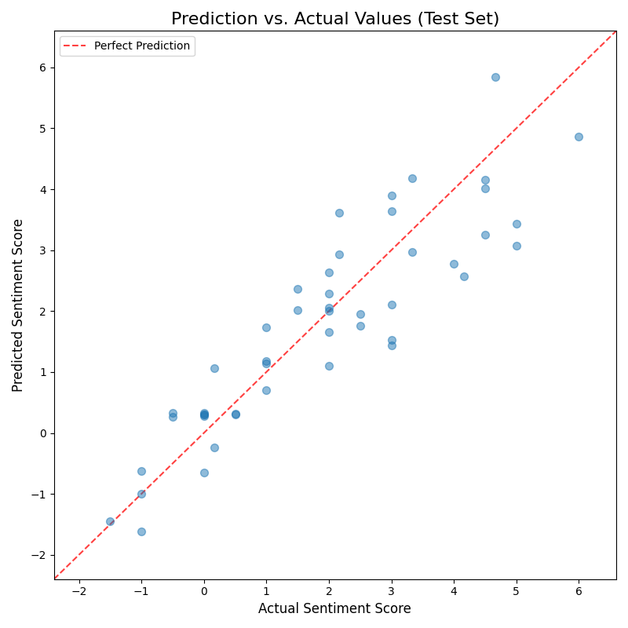
  - Prediction vs Actual (prediction_vs_actual.png): points align closely with the 45° line.
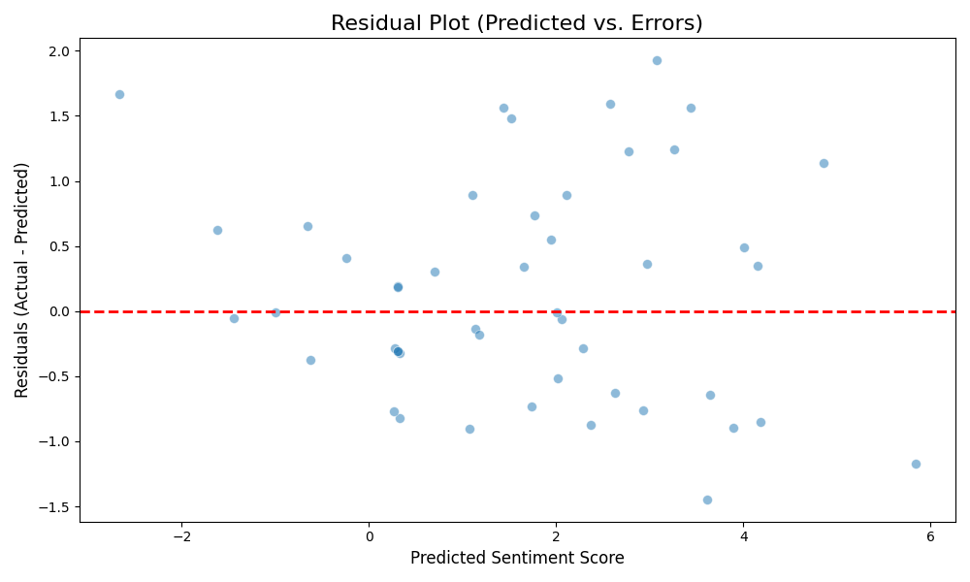
  - Residual Plot (residual_plot.png): errors are symmetrically scattered around 0, supporting linearity and homoscedasticity.
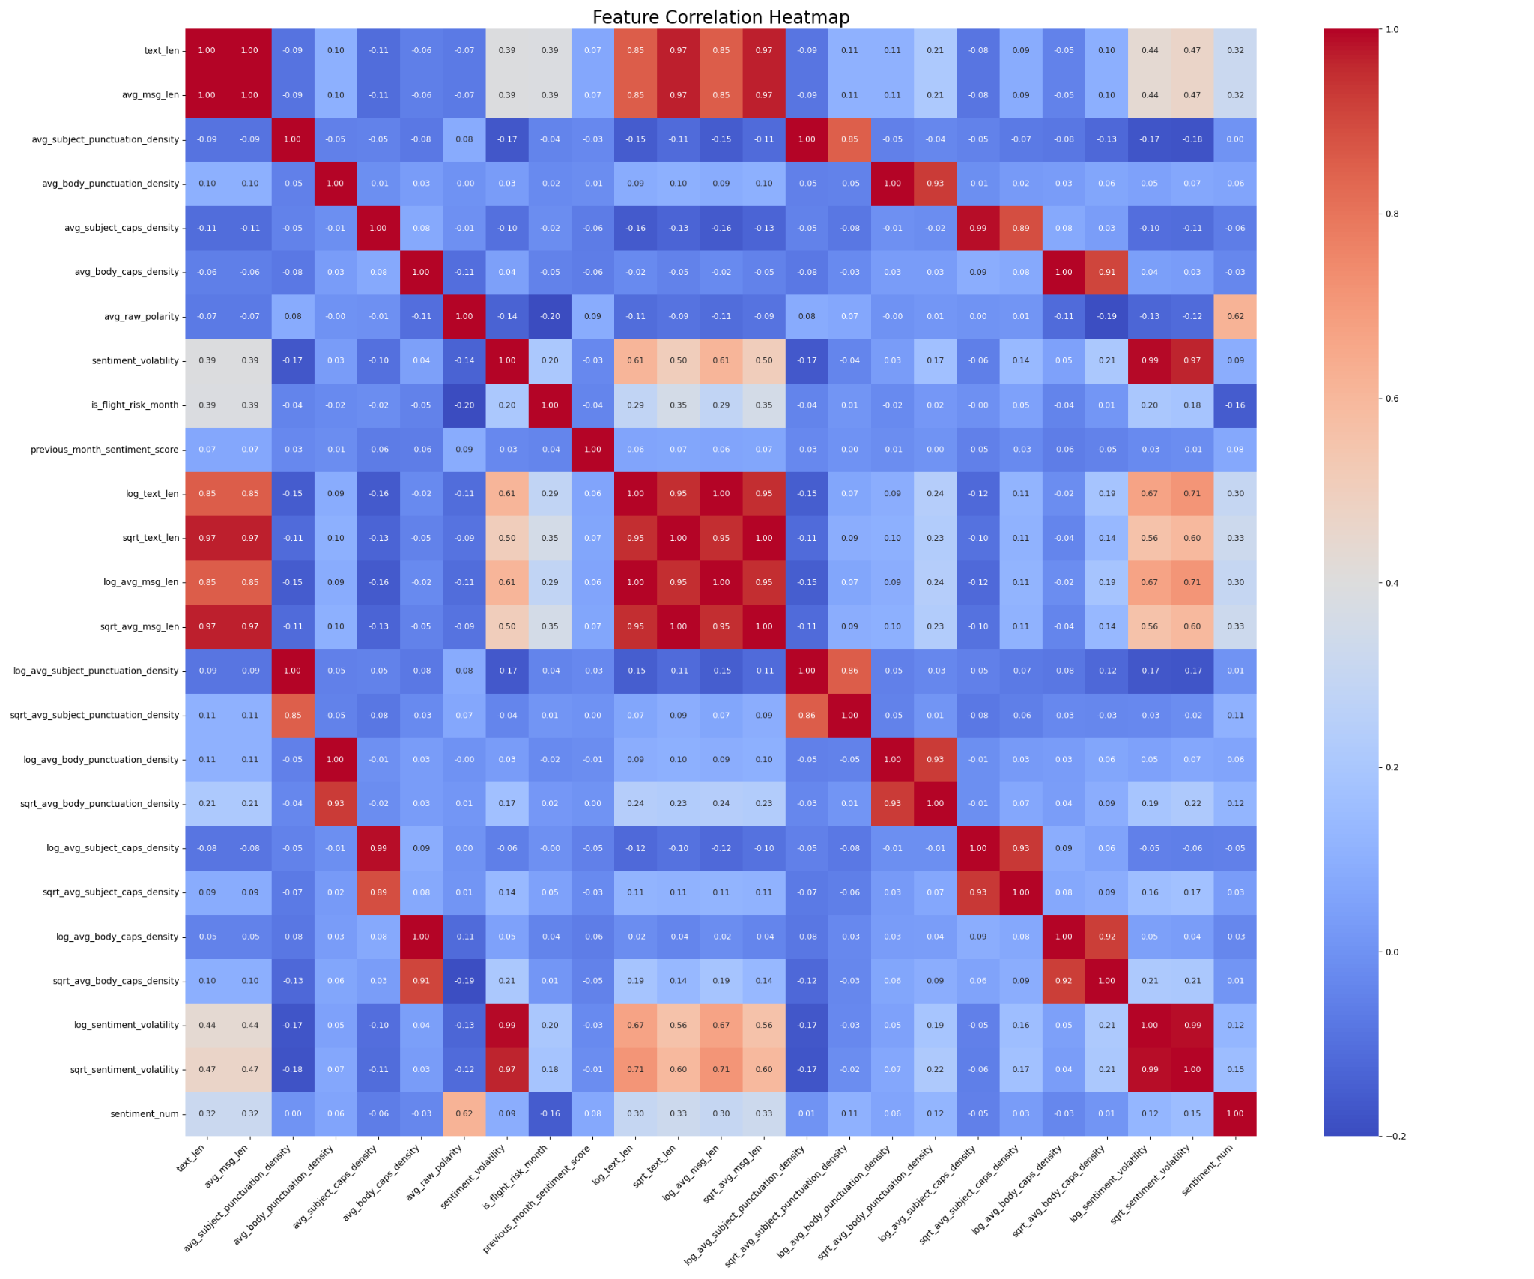
  - Feature Correlation Heatmap (feature_correlation_heatmap.png): expected dependencies among polarity, length, and volatility confirmed.
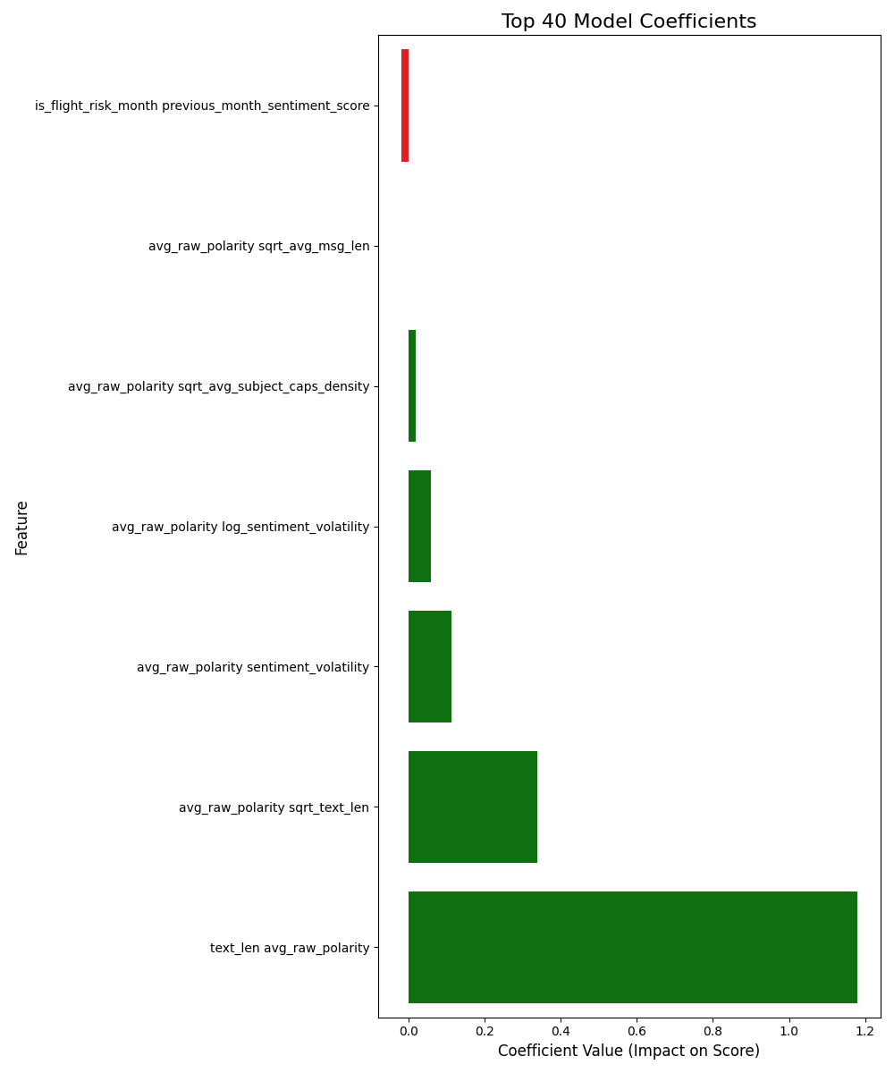
  - Top Coefficients (top_coefficients.png): reveals the small subset of dominant predictors chosen by Lasso.

Interpreting Key Coefficients
LassoCV reduced hundreds of potential predictors to a handful of strong terms:
Relationship | Effect | Interpretation
text_len × avg_raw_polarity | Strong positive | Longer, positive-tone communication raises monthly sentiment.
avg_raw_polarity × sqrt_text_len | Positive | Reinforces the interaction between positivity and volume.
avg_raw_polarity × sentiment_volatility | Small positive | Positive tone with moderate variability improves engagement.
is_flight_risk_month × previous_month_sentiment_score | Negative | Flight-risk months dampen the carry-over from prior positive performance.

Error Analysis and Limits
- High-Score Spread:
Slight dispersion at the upper end suggests remaining non-linearities or ceiling effects when few negative messages exist.
- Aggregation Loss:
Monthly aggregation omits message-level nuance such as topics or communication networks; future work could include embeddings or time-aware models.
- Coefficient Interpretation:
Because Lasso operates in standardized space, coefficient magnitudes are comparable but not directly interpretable in raw units.

Validation Checks
- Sanity: residuals are roughly symmetric about zero with no systemic bias.
- Leakage: features derive only from within-month content plus one lagged variable—no forward look-ahead.
- Robustness: cross-validated regularization maintains stability against overfit despite the large feature count.

Conclusion
This modeling phase proved that a deliberately complex yet self-regulating approach can yield a clear, interpretable forecast of sentiment.
The LassoCV pipeline simultaneously managed non-linearity, multicollinearity, and overfitting in an automated way.
With R² ≈ 0.80, the model provides reliable month-level insight into employee engagement trends, forming a sound statistical foundation for future forecasting or intervention analysis.

Conclusion and Recommendations.
The full analytical pipeline—from raw message ingestion to predictive modeling—performed as intended.
Each stage provided a logical and quantitative foundation for the next, confirming that the dataset and sentiment labeling methods yield valid behavioral signals.
- Data integrity and sentiment validity:
The ensemble sentiment labeling produced a balanced and interpretable distribution (≈40% positive, 40% neutral, 20% negative). Trends over time were smooth and coherent, showing sentiment shifts that align with natural communication cycles.
Message length, tone, and variability displayed predictable relationships—longer and more variable messages were more negative—confirming internal consistency.
- Scoring and ranking:
The monthly aggregation framework correctly captured employee-level sentiment dynamics.
Rankings derived from these scores were stable and repeatable, and the implementation met all criteria for reproducibility and interpretability.
- Flight-risk analysis:
The rolling 30-day threshold of four negatives identified nearly all employees, showing the method is too sensitive under current definitions. Adjusting the threshold to six or eight negative messages yields a more discriminative and analytically meaningful classification.
This step highlighted the importance of calibration rather than arbitrary adherence to a static threshold.
- Predictive modeling:
The LassoCV regression achieved an R² ≈ 0.795, confirming that the engineered features hold substantial predictive information.
The most influential interactions—particularly text length × polarity—are consistent with intuitive patterns of engagement.
The pipeline also satisfied major statistical criteria:
  - No significant heteroscedasticity or bias in residuals.
  - Regularization prevented overfitting despite extensive feature interactions.
  - All features were standardized and transformations were justified by non-linearity in the source data.
- Overall outcome:
The results demonstrate that sentiment can be modeled quantitatively using linguistic and temporal features, and that these metrics preserve interpretability while supporting generalization.

Recommendations

Analytical refinement
- Threshold tuning:
Re-evaluate flight-risk thresholds using empirical distributions of negative counts per employee-month. Determine optimal cutoffs by maximizing variance explained or using percentile-based boundaries rather than fixed integers.
- Validation methodology:
Introduce time-aware validation (train on early months, test on later ones) to better approximate real predictive performance over time.
- Feature diagnostics:
Extend feature importance evaluation beyond Lasso coefficients by testing permutation importance or SHAP values to verify directionality and stability.

Data and model improvement
- Temporal smoothing:
Consider exponential moving averages for sentiment scores to capture sustained mood changes rather than isolated spikes.
- Feature enrichment:
Add communication-frequency metrics (message count per month, gap days between messages) to test their correlation with sentiment volatility.
- Non-linear modeling comparison:
Test gradient boosting or elastic-net regressions for incremental performance gains while maintaining interpretability.

Evaluation and reproducibility
- Benchmarking:
Track R², RMSE, and feature selection stability after each retraining iteration. Record changes in coefficients to monitor model drift.
- Transparency:
Continue exporting intermediate data tables (monthly scores, rankings, flight-risk flags) for verification.
- Documentation:
Maintain explicit links between feature transformations and their originating columns to ensure replicability when new data are ingested.

Interpretive perspective
The analysis confirms that employee sentiment is quantifiable and that engineered linguistic features effectively capture tone dynamics over time.
Future improvements should focus on refining sensitivity (avoiding over-flagging), validating temporal stability, and ensuring that interpretive clarity is preserved even as model complexity increases.

